Practical 5

import java.util.*;

class shape

{

int side_cube;

int l_cub, b_cub,h_cub;

int r_c,h_c;

public shape(int a)

{

side_cube=a;

l_cub=-1; //for other values

r_c=-1;

}

public shape(int l, int b, int h)

{

l_cub=l;

b_cub=b;

h_cub=h;

side_cube=-1;

r_c =-1;

}

public shape(int r, int h)

{

r_c=r;

h_c=h;

side_cube=-1;

l_cub=-1;

}

public static void main(String args[])

{

shape cube= new shape(5);

shape cuboid= new shape(2,3,5);

shape cylinder= new shape(3,5);//random values assigned, values can be taken from user as well

volume(cube);

volume(cuboid);

volume(cylinder);

}

public static void volume(shape obj)

{

if(obj.side_cube<0 && obj.r_c<0)

{

System.out.println("Volume of the cuboid: "+(obj.l_cub*obj.b_cub*obj.h_cub));

}

else if(obj.side_cube<0 && obj.l_cub<0)

{

System.out.println("Volume of the cylinder: "+(double)(3.14*Math.pow(obj.r_c,2)*obj.h_c));

}

else

{

System.out.println("Volume of the cube: "+(Math.pow(obj.side_cube,3)));

}

}

}

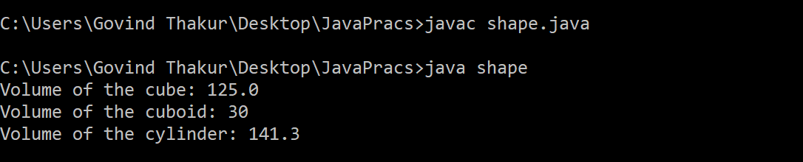OUTPUT: